**`Analiza układu**

|  |  |  |  |  |  |
| --- | --- | --- | --- | --- | --- |
| 0 | 0 | 0 | 0 | 0 | 0 |
| 0 | 0 | 1 | 0 | 0 | 0 |
| 0 | 1 | 0 | 0 | 0 | 0 |
| 0 | 1 | 1 | 0 | 0 | 1 |
| 1 | 0 | 0 | 1 | 0 | 0 |
| 1 | 0 | 1 | 1 | 1 | 0 |
| 1 | 1 | 0 | 0 | 1 | 0 |
| 1 | 1 | 1 | 1 | 1 | 1 |

**Synteza układu synchronicznego, wykorzystującego dwa przerzutniki JK**

|  |  |  |  |  |  |  |  |  |
| --- | --- | --- | --- | --- | --- | --- | --- | --- |
| 0 | 0 | 0 | 0 | 0 | 0 | – | 0 | – |
| 0 | 0 | 1 | 0 | 0 | 0 | – | – | 1 |
| 0 | 1 | 0 | 0 | 0 | – | 1 | 0 | – |
| 0 | 1 | 1 | 0 | 0 | – | 1 | – | 1 |
| 1 | 0 | 0 | 1 | 0 | 1 | – | 0 | – |
| 1 | 0 | 1 | 1 | 1 | 1 | – | – | 0 |
| 1 | 1 | 0 | 0 | 1 | – | 1 | 1 | – |
| 1 | 1 | 1 | 1 | 1 | – | 0 | – | 0 |

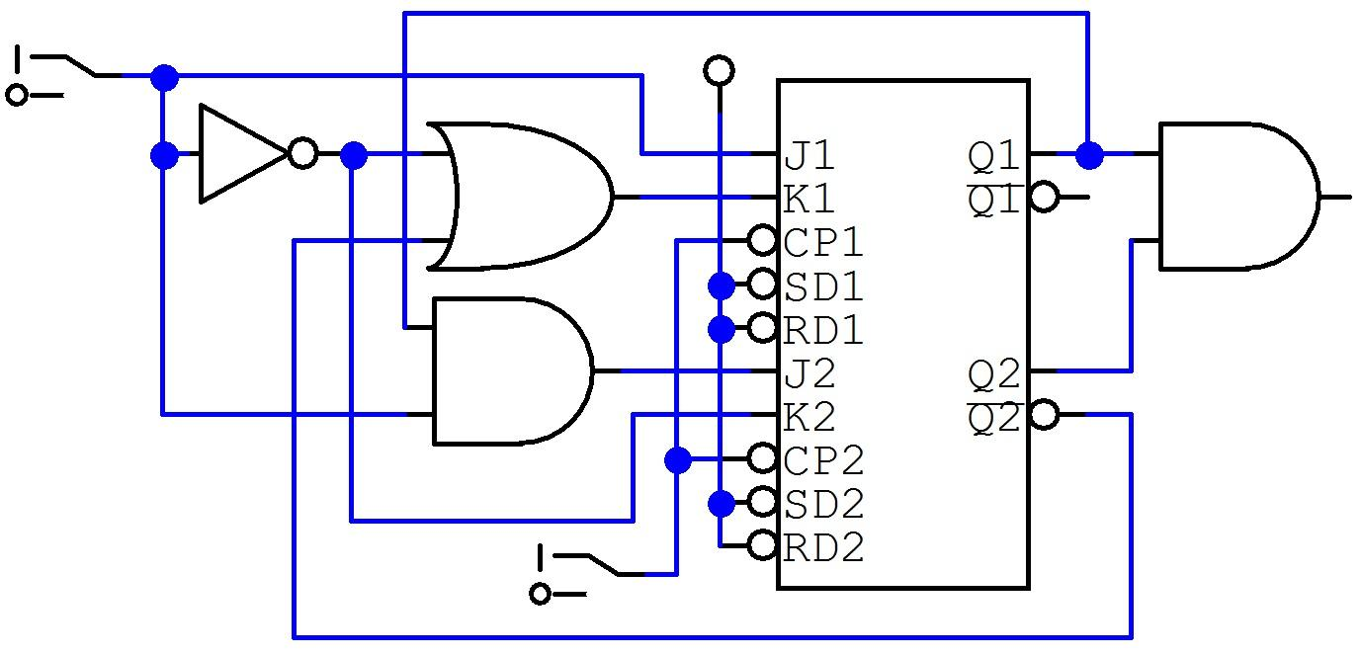

| czas | t5 | t4 | t3 | t2 | t1 | t0 |
| --- | --- | --- | --- | --- | --- | --- |
| x | 1 | 1 | 1 | 1 | 0 | 0 |
| y1y2 | 11 | 11 | 01 | 10 | 00 | 00 |
| Z | 1 | 1 | 0 | 0 | 0 | 0 |

